The information in this section is an extract from the DOORS module identified by the following information.
DOORS module path: /TERMA DOORS/IDS/Naval/Naval C2/Common Features/2. System Level Requirements/
DOORS module name: 2122830-DT
DOORS module description: DLS System Requirements
DOORS baseline version: 1.7
DOORS view: RDN view

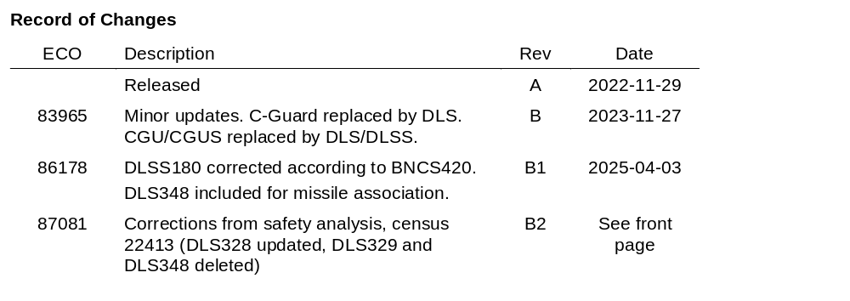

Contents
1 Decoy Launcher System 4
1.1 Introduction 4
1.1.1 Purpose 4
1.1.2 Application 4
1.2 References 4
1.3 Definitions 4
1.4 Reader's guide 4
1.4.1 Form 4
1.5 Roles/Personas 5
1.6 Execute Common Missions and Tasks 5
1.6.1 Perform Anti-Ship Missile Defense 5
1.7 Control and Monitor Sub-systems 6
1.7.1 Control and Monitor the DLS System 6
1.8 System Safety 6
1.9 System Interfaces 7
1.9.1 DLS 7

Decoy Launcher System

Introduction

Purpose
Describes the Decoy Launcher System (DLS) functionality for Naval C2 systems via User Scenarios.

Application
Used for communicating needs to system engineers, software developers, testers, and managers for Naval C2 products and projects.

References
Ref. Doc. No. Title
[BNC] 2017969-DT Basic Naval C2 System Requirements
[DLSS] 2122830-DR DLS Stakeholder Requirements
[DLS-IDD] IDD 312899 C-Guard Interface Specification, Rev G

Definitions
Term Definition
DLS Decoy Launcher System
HW Hardware
IEEE The Institute of Electrical and Electronics Engineers, Inc
IR Infrared
LAN Local Area Network
LCC Launch Control Computer
LIU Launcher Interface Unit
MWSS Main Weapon Safety Switch
RF Radio Frequency
SE System Engineer
SW Software
WMS Weapon Management System

Reader's guide

Form
This document must be read in conjunction with the Basic Naval C2 User Scenarios [BNC]. The User Scenarios in this document is intended to augment and be placed in the same hierarchical structure as defined in [BNC].
Requirements are given as user scenarios, and only aspects poorly suited for user scenarios are given as line requirements.
The terms "shall" and "must" are used to specify mandatory aspects (i.e. for essential features), whereas the term "should", is used to denote desirable but non-essential aspects. The term "shall not" and "must not" are used to denote aspects that are unacceptable or prohibited.
For the user scenarios, the form is a base statement:
As a <role>, I want <some goal>, so that <some reason/business value>
followed by some comments giving context to the base statement.
This shall be augmented with accept criteria that defines what must be fulfilled for the delivered functionality to be accepted. Accept criteria pertains to the solution, not the process.
To get sufficient coverage of needs, user scenarios can be at multiple abstraction levels. Each subsection shall act as an Accept criteria for the overlying user scenario. Only the lowest level of Accept criteria are marked as Requirement.
Please note that a user scenario is not meant to be a complete specification. Rather, it shall be a vehicle for conversation between developers/architects and "customers", and the accept criteria shall specify only the truly important parts - not everything the author can possibly think of.

Roles/Personas
This section outlines the user types that are stakeholders in a Naval C2 system.
Role Definition
Operator Normal non-privileged runtime user of the system.
Warfare Operator Warfare Operator is as Operator but also specialize in warfare operations.
Safety Engineer Supplier employee (SE) that defines precautions to minimize safety critical hazards to an acceptable risk level.
System Configurator Supplier employee that (at pre-delivery time or at least off-line) configures or sets up the system. Normally SW developers or SEs.

Execute Common Missions and Tasks
[DLSS130] As an Operator, I want tools that can help me execute common patrol missions, so I can achieve my goal.

Perform Anti-Ship Missile Defense
[DLSS132] As an Operator, I want to perform Anti-Ship Missile Defense, so I can protect my own ship from incoming missiles.

Designate Tracks for DLS
[DLSS133] As a Warfare Operator, I want to designate targets to the DLS system, so I can divert incoming missiles away from my ship.
Accept Criteria
^{DLS351} • I want to be able to designate up to 4 targets.
^{DLS352} • I want the system to only allow DLS designation of tracks that are category: Air or Unknown, and with the identity: Hostile, Suspect, Pending or Unknown.
^{DLS152} • I want that designated target data is forwarded to the DLS system periodically.
^{DLS243} • I want to be able to see why a designated threat cannot be included in a firing proposal.
^{DLS214} • I want to be able to see targets designated to DLS as designation symbols on the Situation Display.
^{DLS155} • I want to be able to terminate a designation at any time.

Control and Monitor Sub-systems
[DLSS135] As an operator, I want to control and monitor the sub-systems available in my configuration.

Control and Monitor the DLS System
[DLSS137] As a Warfare Operator, I want to control and monitor the DLS system, so that I am aware of its operational status and working mode.
----------------------------------------
The DLS function interfaces the Launch Control Computer (LCC), which calculates firing proposals and controls firing of decoys from non-trainable multiple-tube launchers. The tubes point at various fixed angles around the ship.
Accept Criteria
^{DLS170} • I want the system to continuously provide the DLS subsystem with wind and other own unit data.
^{DLS261} • I want to be able to specify manual wind data to be used by DLS instead of the values used in the system.

Allocate DLS
[DLSS138] As a Warfare Operator, I want to be sure that I am the only one controlling the system, to ensure safe operations.
Accept Criteria
^{DLS353} • I want to be able to take exclusive control of the DLS from a console.
^{DLS175} • I want to be able to release my control of DLS.
^{DLS176} • I want the system to automatically release control of DLS if my console crashes/develops a fault.

Monitor Status of the DLS system
[DLSS139] As a Warfare Operator, I want to be given status information about the state of the system, so I can ensure safe operation.
Accept Criteria
^{DLS213} • I want to be able to see status of the system.

System Safety
[DLSS178] As a Safety Engineer, I want to enforce safety precautions, so the system can best possibly avoid safety hazards.

Safe Operation of DLS
[DLSS147] As a Safety Engineer, I want to enforce safe operation of DLS, so I can avoid unintended firing of decoys.
Accept Criteria
^{DLS255} • [Safety] I want the system to prevent allocation of DLS and firing of decoys, when the LCC is degraded.
^{DLS337} • [Safety] In operational mode, I want that it is not possible to designate or otherwise forward information for any simulated track to DLS.

System Interfaces
[DLSS154] As a System Configurator, I want that the system implements specified subsystem interfaces, so I can ensure proper integration of all interfaced subsystems.

DLS
[DLSS155] As a System Configurator, I want that the system implements the specified DLS interface, so I can ensure proper integration with the subsystem.
----------------------------------------
The Launch Control Computer (LCC) is a workstation type computer that contains a fast microprocessor and engagement algorithms in software. The algorithms are used for calculating the optimal engagement proposals for firing decoys as response to anti-ship missile attacks.
The LCC is interfaced to two Launcher Interface Units (LIU) for controlling launch of the tubes and reading the tube content and the launcher system status.
Accept Criteria
^{DLS241} • I want the system to implement the DLS interface in compliance with Doc. no IDD 312899 [DLS-IDD].
^{DLS354} • I want the electrical interface to comprise an Ethernet LAN interface based on IEEE 802.3 1000Base-TX copper.

